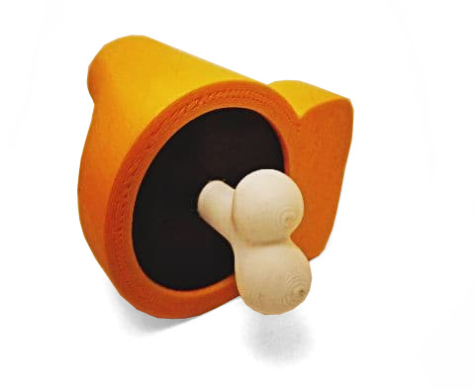

AmongUs Figure
Contact: nopx
Projectstatus: 

Summary
I printed this Thingiverse Among Us Figure here.

Pictures


