

EURO One CPU
Contact: nopx
Projectstatus: 

Summary
I currently creating my own CPU from scratch. At first I am running it in Logisim, a logic simulator but I planed to build a simplier version in hardware subsequently. Here is the overview on the current state of the simulated CPU:
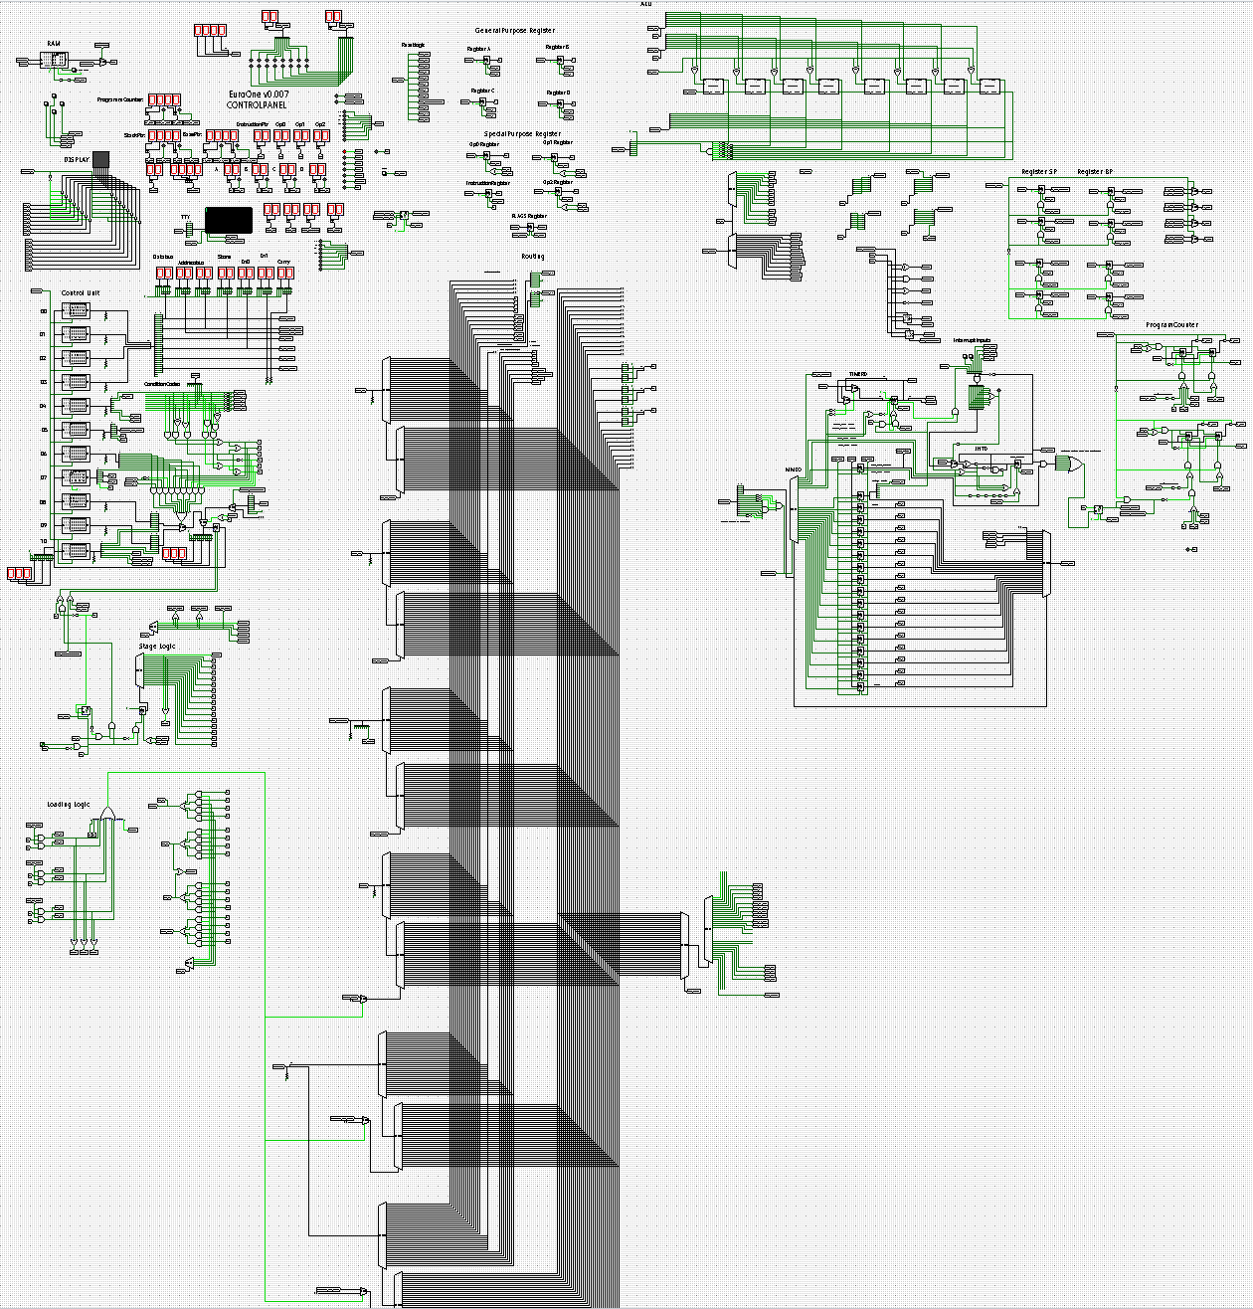

Control Panel
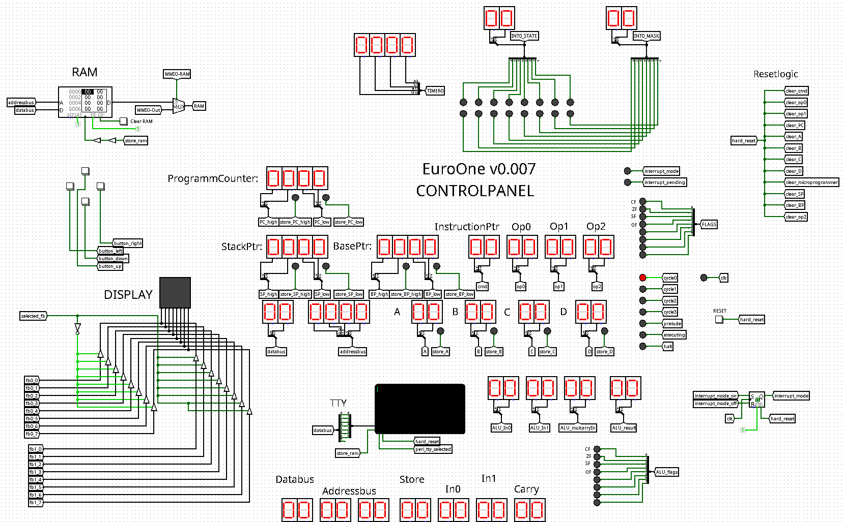

Microcode Processing
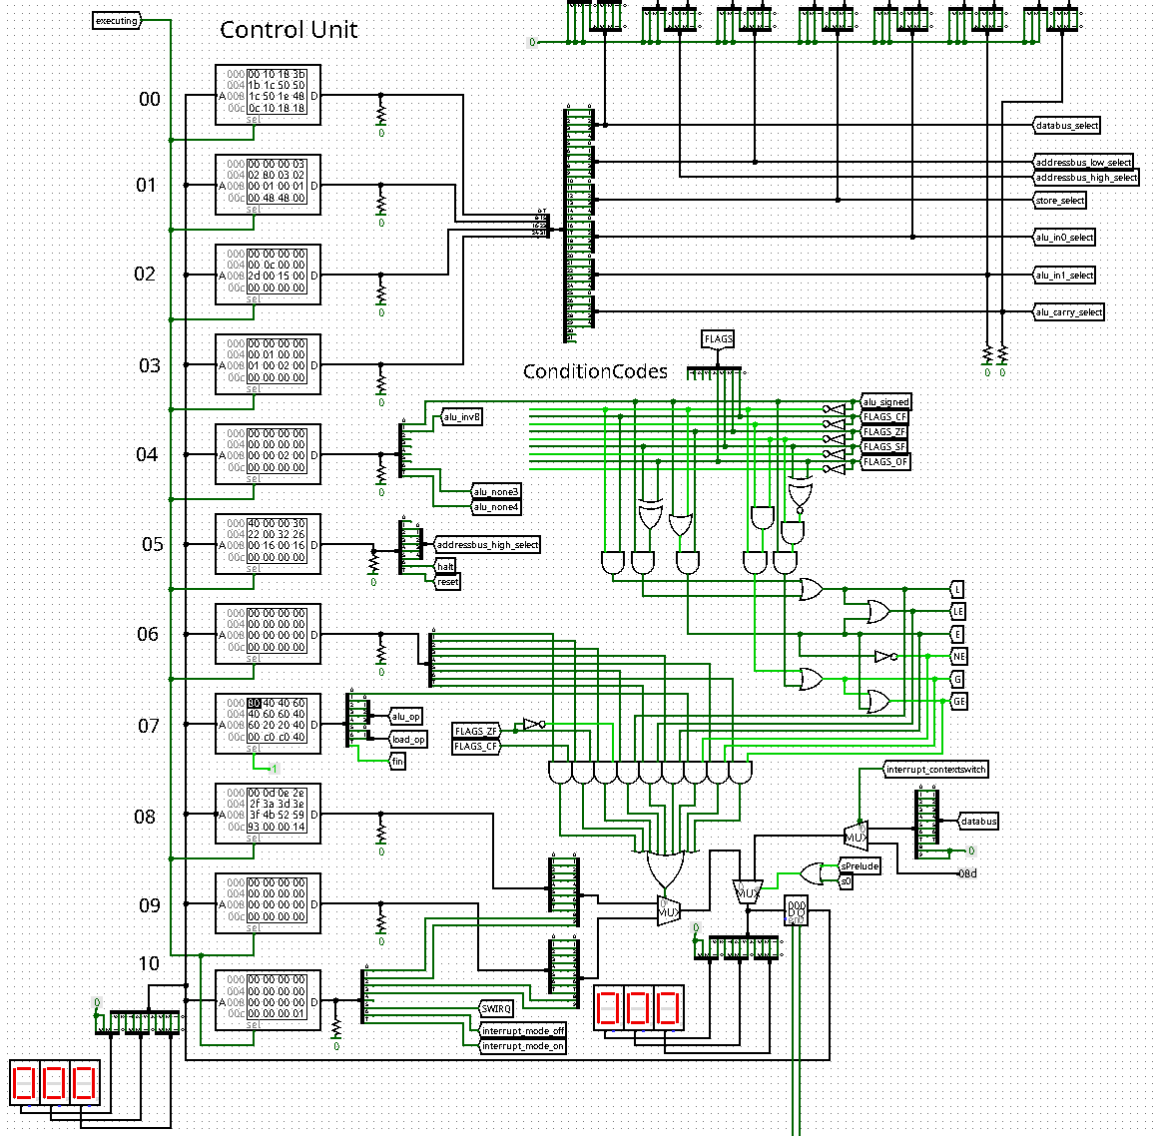

State Logic
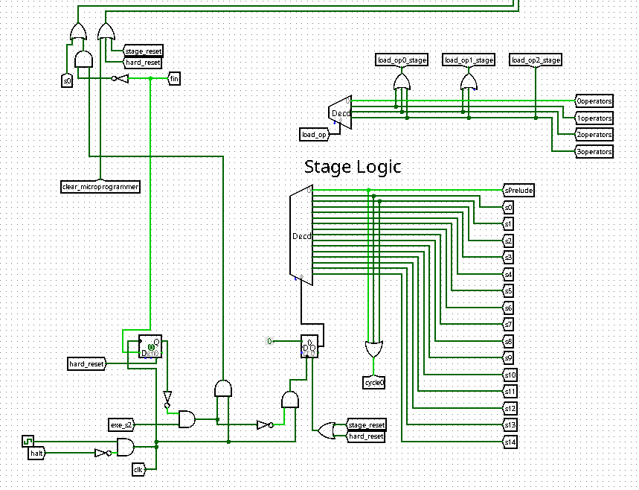

Loading Logic
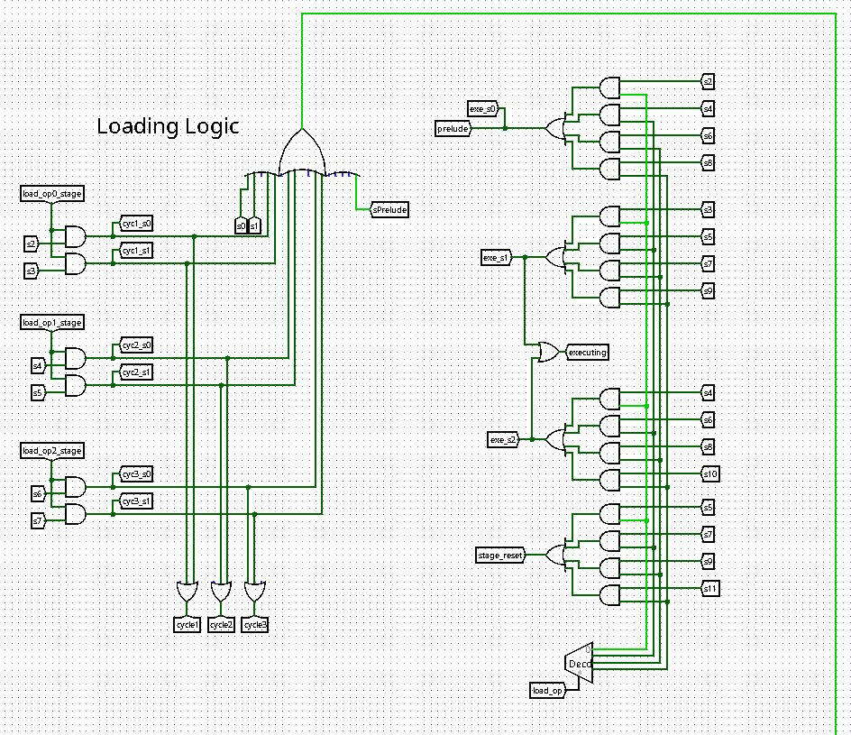

Memory-Mapped IO, TIMER0, and INT0
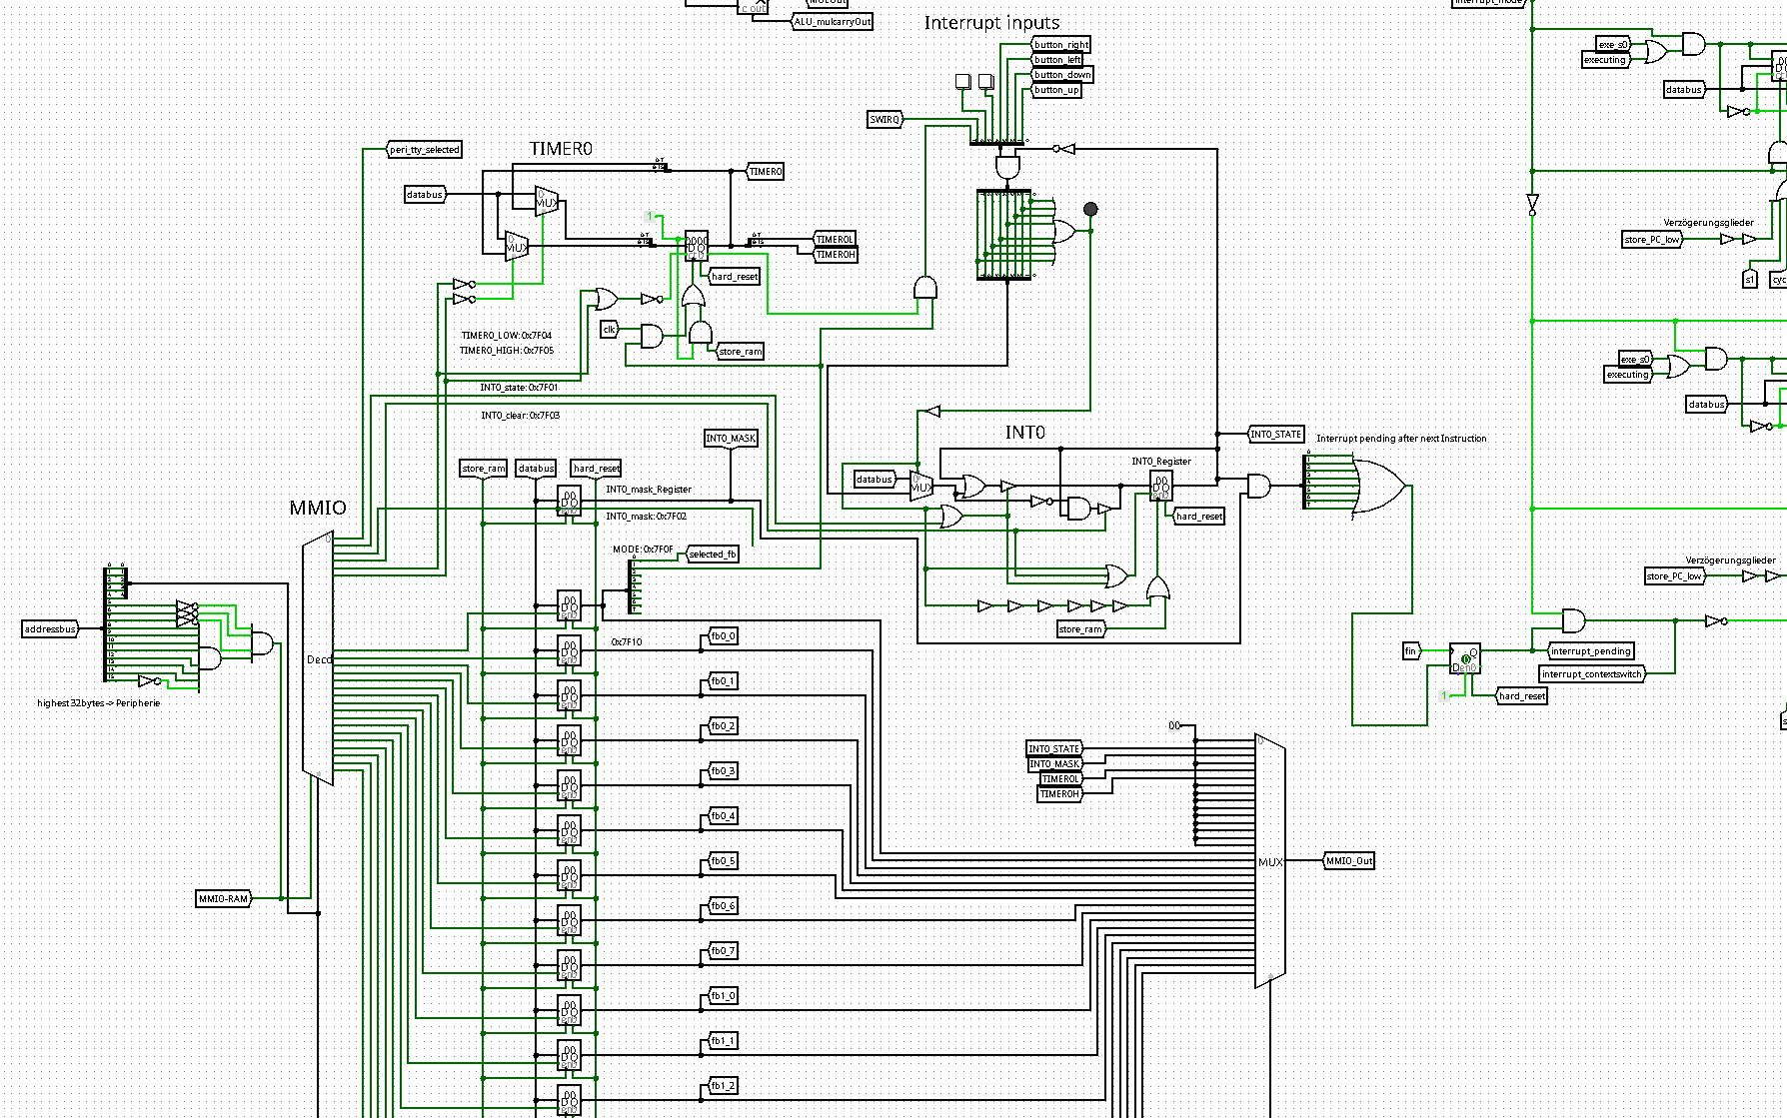

Status

2020-05
I finished the pre-project: 4Bit Relay Adder to gain some insights into relay logic. I decided to first build a much simpler 4 bit cpu from relays, without any transistor. You find the documentation of this second pre-project here: EuroTwo CPU.

Documentation
As I cannot document it here in detail I will upload my documentation from time to time.
- EuroOne v0.005 Documentation [PDF]
- EuroOne v0.006 Documentation [PDF]

Planned and ideas
- Add UART Controller from ATMEGA32

