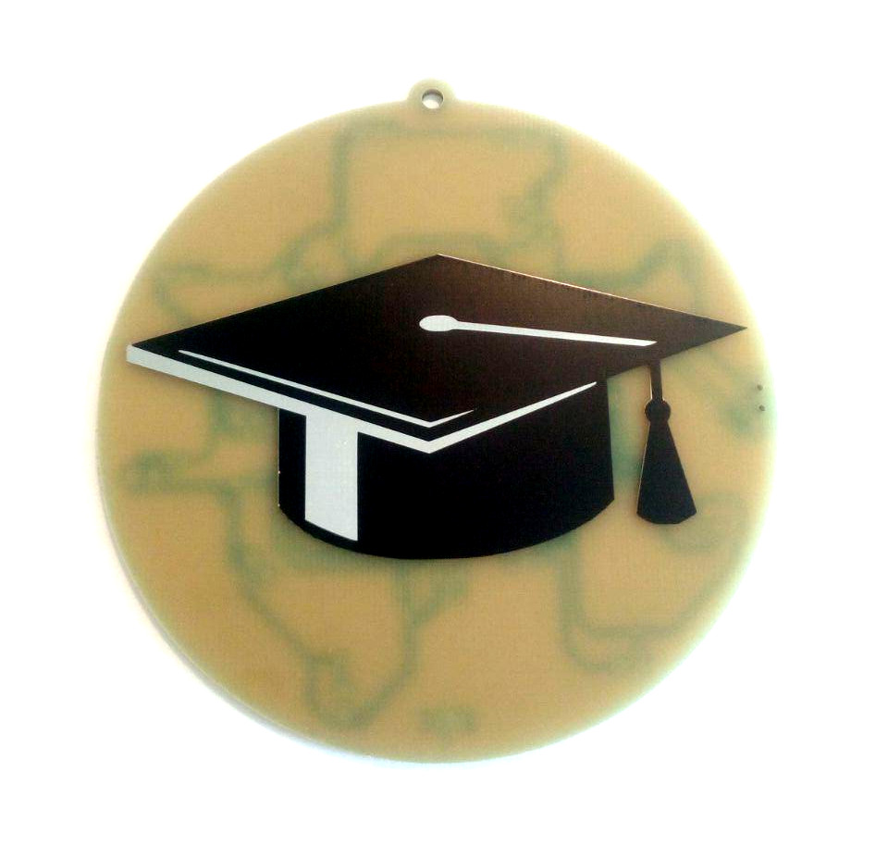

Graduation Badge
Contact: nopx
Projectstatus: 

Summary
As a lot of my friends graduated 2020, I made a little graduation badge.

Pictures


