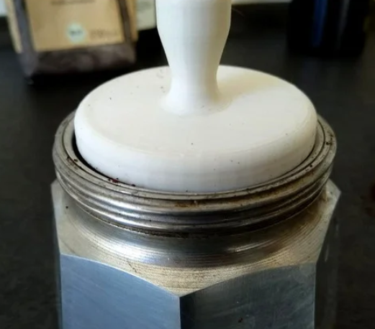

Espresso Temper 55mm
Contact: nopx
Projectstatus: 

Please find the project page here: https://www.thingiverse.com/thing:4811312

