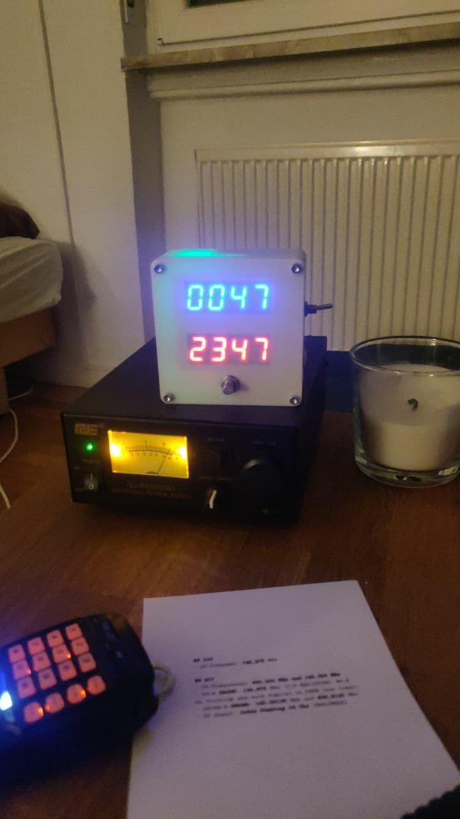

UTC Clock
Contact: nopx
Projectstatus: (Nov 2021)

Project Goal

Hardware

Software

