

EuroTwo CPU
Contact: nopx
Projectstatus: 
Documentation: here.
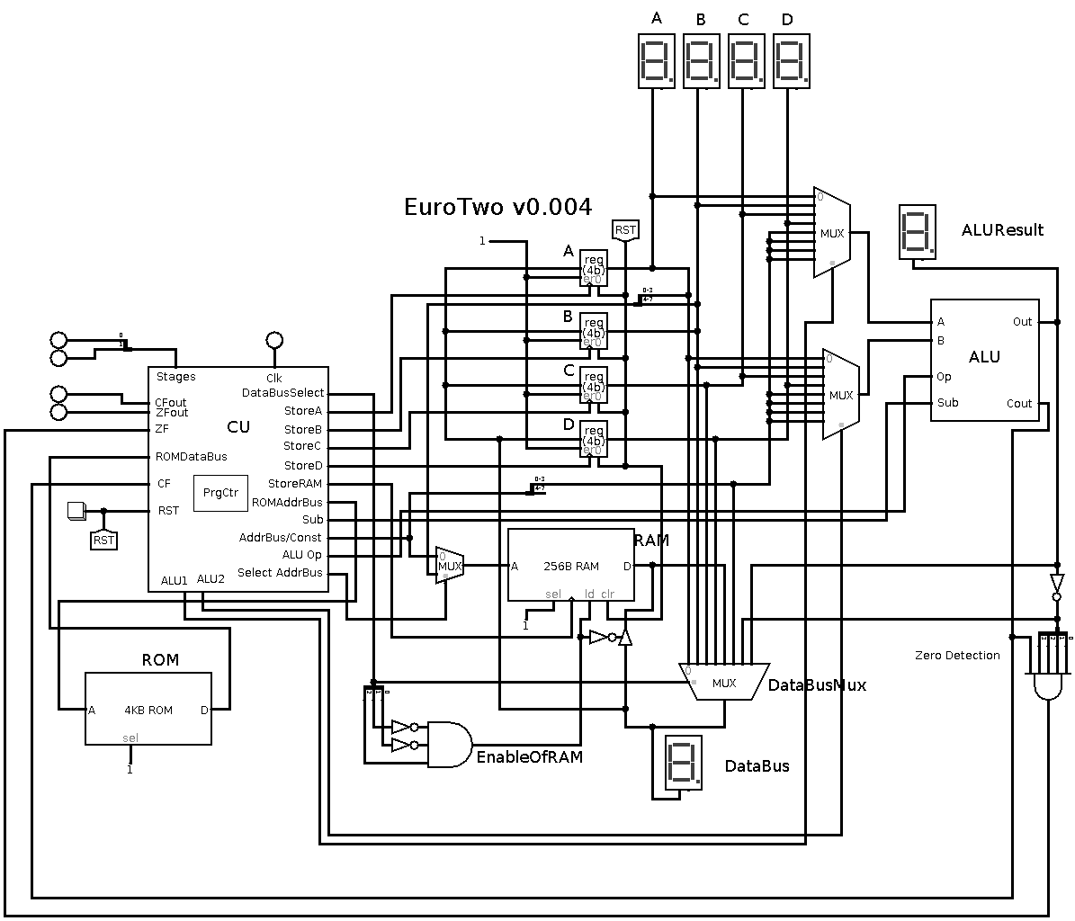

Status

2021-01-02
I made a bunch of power cables today. Also I ordered a lot of screws and other stuff. Hopefully tomorrow my board will arrive!
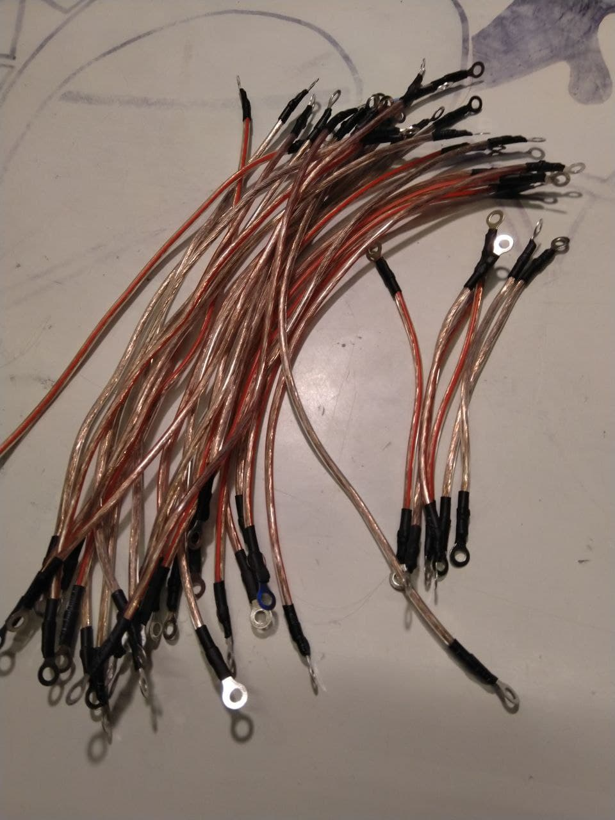

2020-12-31
I soldered 5 more MUXs. Also I ordered ~100 new PCBs. Distributors, HalfAdders, LogicBlocks like Inverters and stuff, and also a Digital Controller to simulate ROM, RAM, and the ControlUnit. The plan is to replace the DigitalControllers bit by bit. Starting with the control unit. Assumed I own enough cables, clips, relays and screws I should own everything to have a running CPU in the next few days.
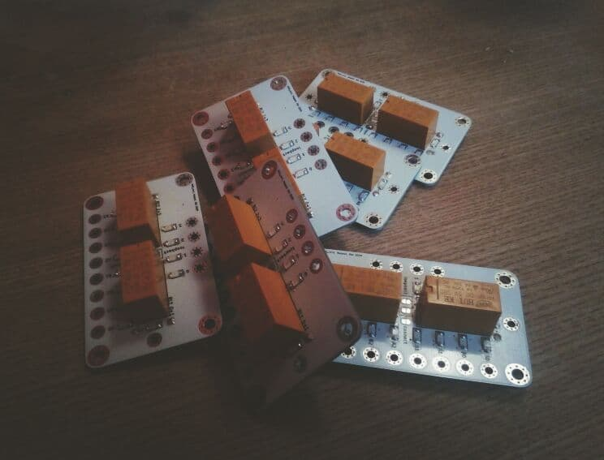

2020-10-28
I tried a different setup of the logo illumination by using two PCBs. I sanded the backside of the first PCB and assembled the LED in the other direction on the second one. This look much smoother and better!
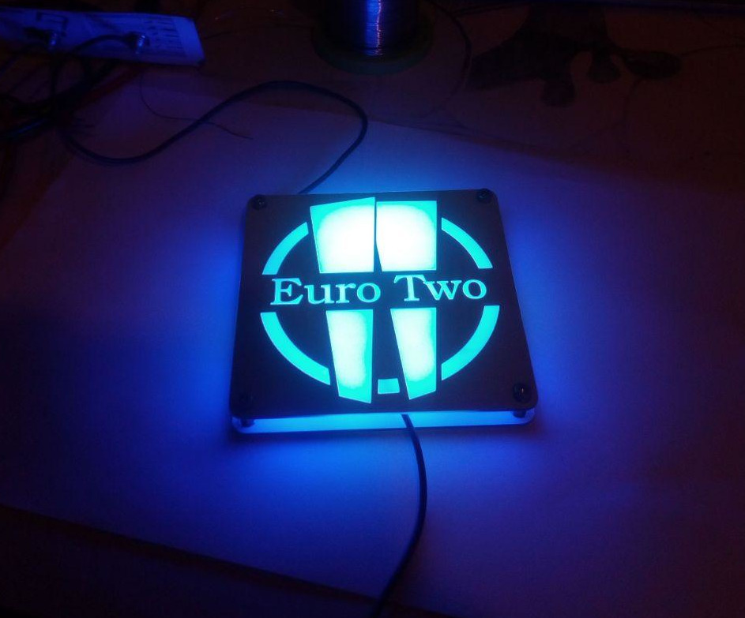

2020-10-18
Testing worked fine. Design looks nice.
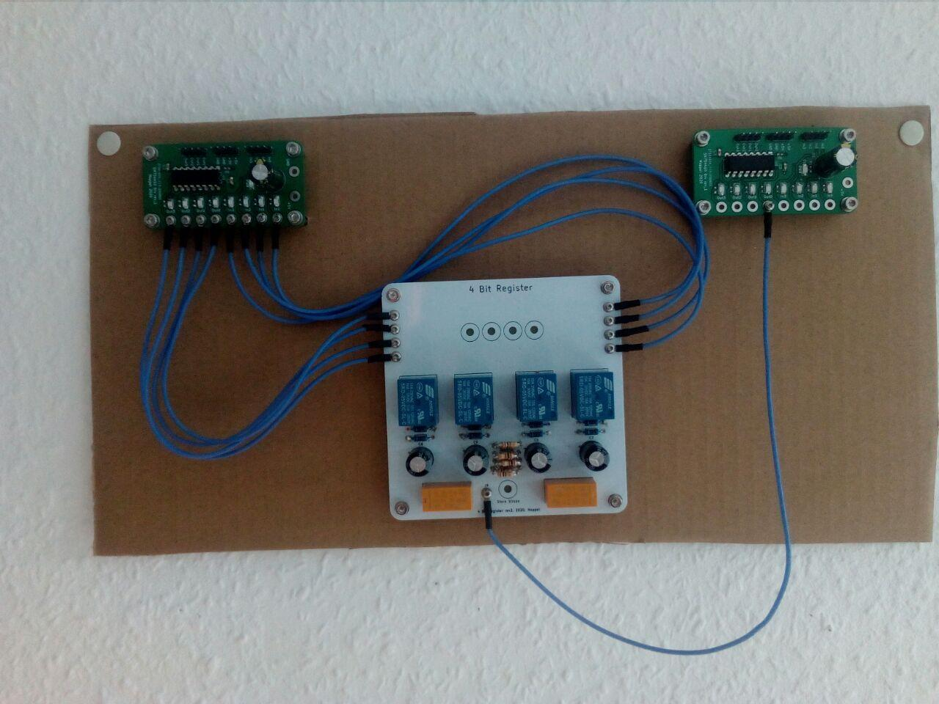

2020-08-10
I designed a testing board with a SN754410 H-Bridge driver for testing. I can test 4 outputs and 4 inputs per testing board easily with an Arduino now. The SN754410 is still in delivery and will get assembled later. Tweet, including a short video of the testing
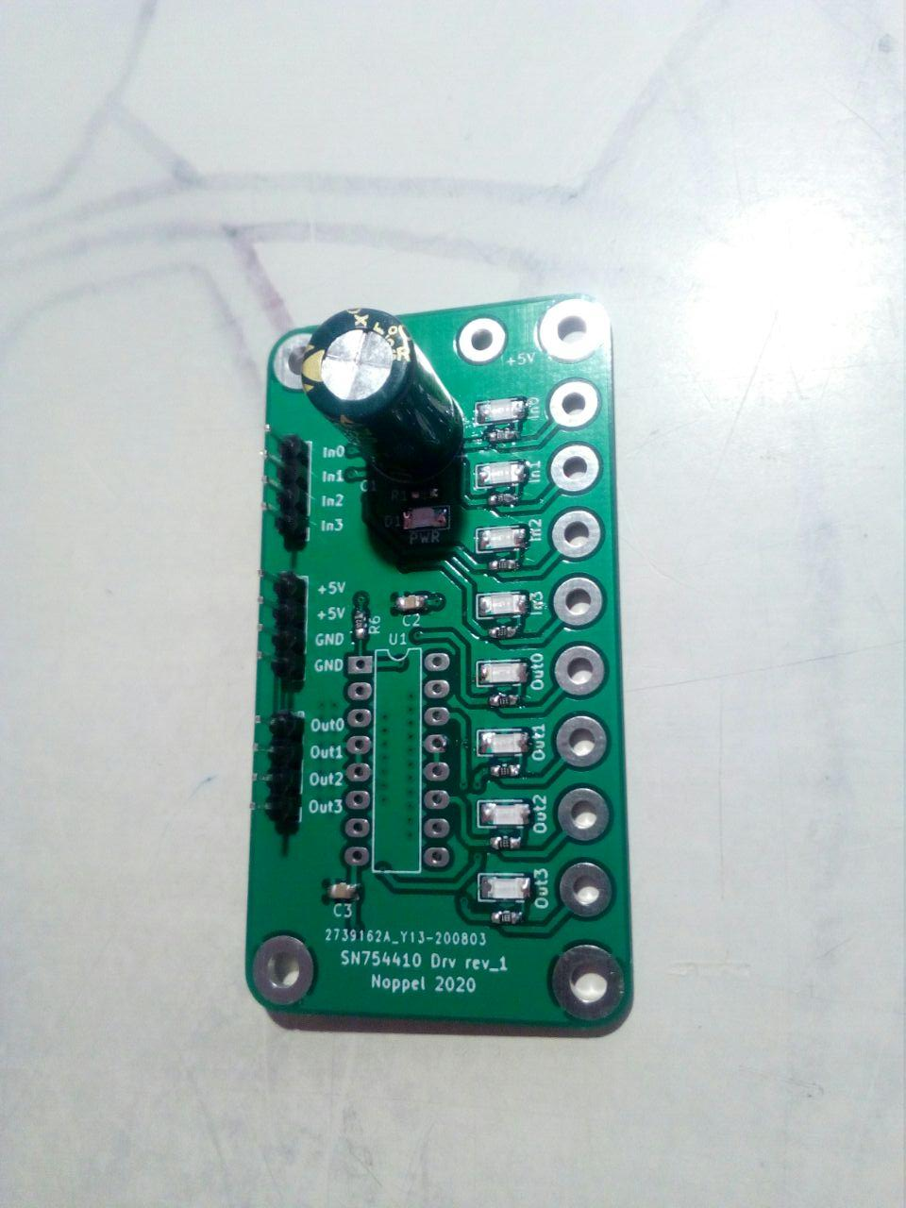

2020-08-01
My automated long term test is up and running. 1000 test-iterations per bit. Tuned the loading speed of the C (adding 100 Ohms), added diodes (1N4007) and tuned the holding voltage of the relais better by adding 100 Ohms.
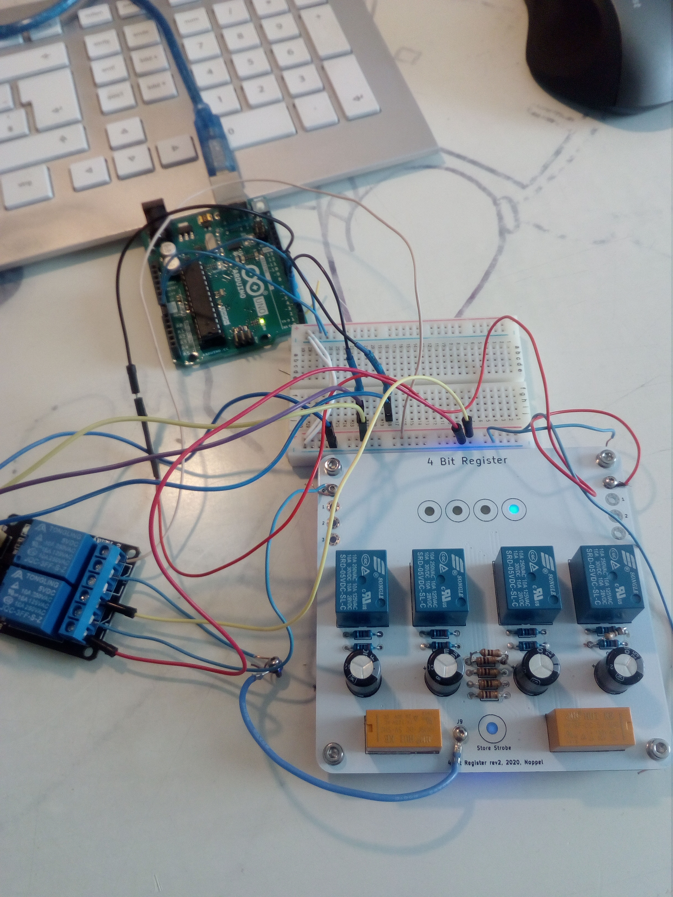

2020-06-28
Fixed the „4-Bit Register rev2“ board. The board is fully functional but has some drawbacks. You need to scratch away 8 traces on the board and solder 8 short wires on it.
The fixes for rev3 are:
- Cs were not aligned correctly to matching relais. Nobody will see this but still, it is not as intended! Fixed in rev3
- There is a mistake at the store relays. That is why you need to scratch traces. Fixed in rev3
- Rev2 is unable to select between rising and falling edge. This is fixed in rev3 by a jumper
- B.Mask is under the LED-Indicator on the back, that is why the light is not as bright as intended. Fixed in rev3.
- Numbering of the LEDs would be helpful. Fixed in rev3.

2020-06-18
The PCBs for the 4Bit Register and the Logo did arrive. I assembled them successfully. I'm now waiting for the new Relays HK19F for the final test of the registers. In the Logo-PCB there was a little mistake but I succeed fixing it by scraping away two traces.
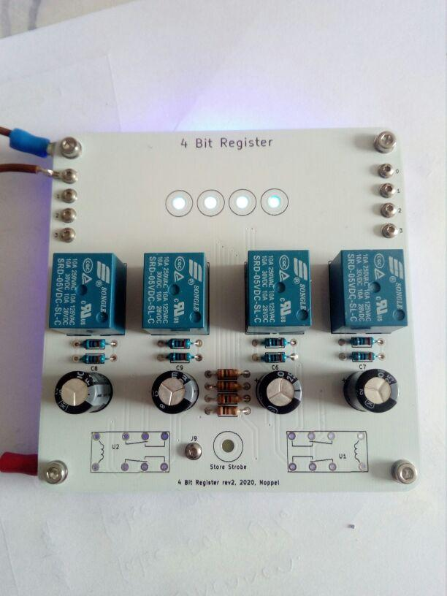
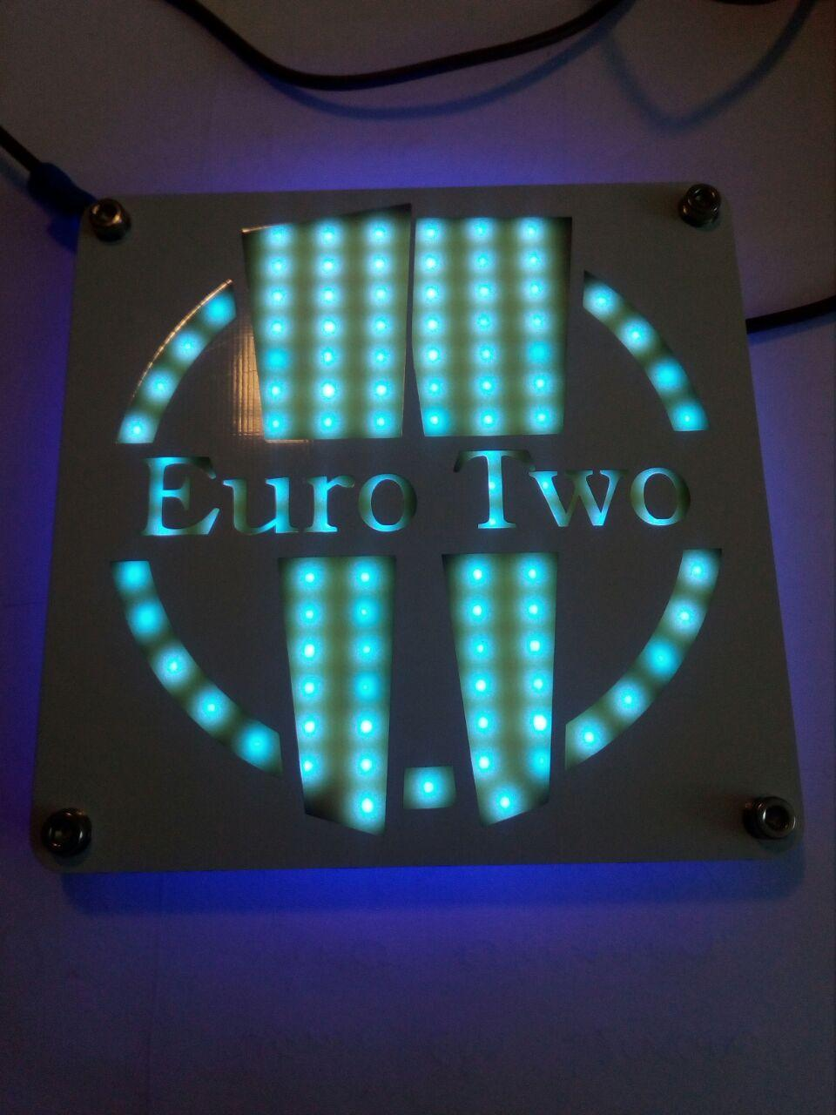

Documentation

Downloads
- EuroTwo v0.002 Manual [PDF]
- EuroTwo v0.004 Manual [PDF]
- EuroTwo OnePiece v0.004.0 Schematic [PDF] (untested)

Sizes/Standards
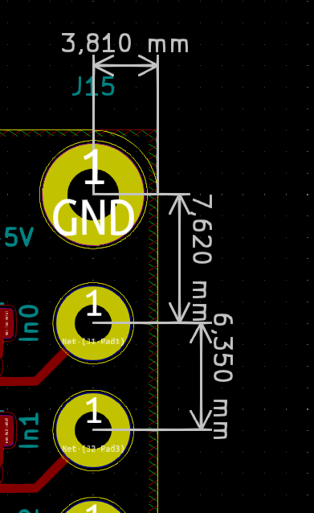
- Holes for signals: 2_2mm vias or pads
- Holes for currents: 3.2
- GND on top holes
- +5V on bottom holes

Errata

HalfAdder rev1
- Silkscreen AxorB → A&B

DigitalController v1
- https://www.mikrocontroller.net/topic/477873

