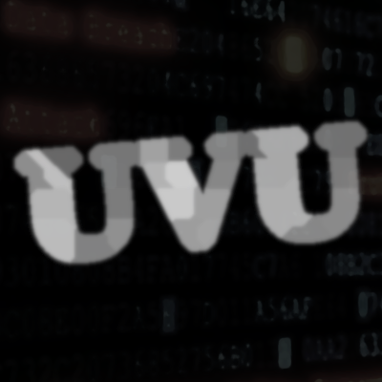

002: UVU
Serie | treffen:problemsolving
Von | nopx
Datum | 06.Juli 2021
Download | Aufgabenbeschreibung [pdf,v2]
Schwierigkeit
Some unittests
#!/bin/python
import unittest
from main import eval
class Test(unittest.TestCase):
def test(self):
self.assertEqual(1, eval("aba"))
self.assertEqual(1, eval("abcbabc"))
self.assertEqual(1, eval("abcabc"))
self.assertEqual(1, eval("aa"))
self.assertEqual(0, eval("a"))
self.assertEqual(0, eval(""))
self.assertEqual(1, eval("a" * 498 + "b" + "g" + "b" + "a" * 498))
self.assertEqual(1, eval("a" * 497 + "b" + "ghg" + "b" + "a" * 497))
self.assertEqual(1, eval("aaahalloa"))
if __name__ == "__main__":
unittest.main()

Lösungen


nopx
def eval(s):
for i in range(1,1+len(s)//2):
if s[:i] == s[-i:]:
return 1
return 0
~~DISCUSSION~~

