Pixtxa
Avatar
Pronouns | π/she/her
Contact | Please see nohello.net or I might ban
Language | DE 🇩🇪 / EN 🇬🇧
Joined | 2018-04-01
Birthyear | 1993
Adjectives | ace/asexual (acarnal, sex-indifferent), cuddle starved, introvert/ambivert, neurodivergent (AuDHD), panamorous, polyamorous, platonic-positive (sensual, touch-friendly), queer-platonic, shy, transfeminine
Event visits | 39CE@Basel, DHCP2025, 14. Backspacegeburtstag, MRMCD2025, Geekend: 25 Jahre CCCBasel, GPN23, CoSin 2025, 38C3, MRMCD2024, IGERla2024, GPN22, UnFUCK2024, EH21, MRMCD2023, CCCamp2023, IGER2023, GPN21, UnFUCK2023, IGER2022, GPN20, 36C3, UnFUCK2019, CCCamp19, GPN19, IdeenPark2008, Expo2000
DECT | 7498 (Eventphone), 3773 (EP-VPN)
Mastodon | @Pixtxa@chaos.social
Printables | @Pixtxa_1322683
GitHub | Pixtxa
ListenBrainz | Pixtxa
PokemonGo | Pixtxa 5506 6542 9288
Steam | Pixtxa
Instagram | @Pixtxa
BARQ! | @Pixtxa
Matrix | @Pixtxa:matrix.org
Signal | Pia.31
Telegram | @Pixtxa
Discord | Pixtxa
E-Mail | Pixtxa@[domain of this space]
Other | Pixtxa

Projekte
Klingel-Thermometer
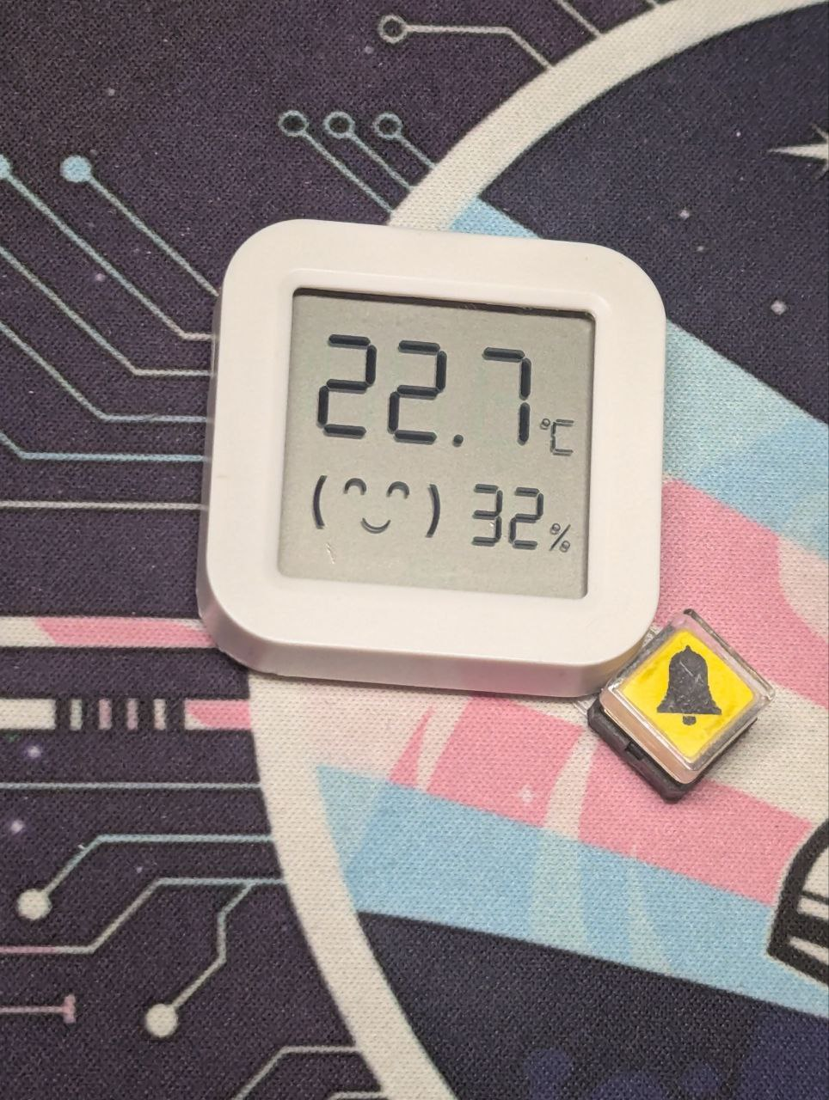
Zugangswegzeitraffervideo
zugangswegzeitraffervideo1.mp4
Transpotter
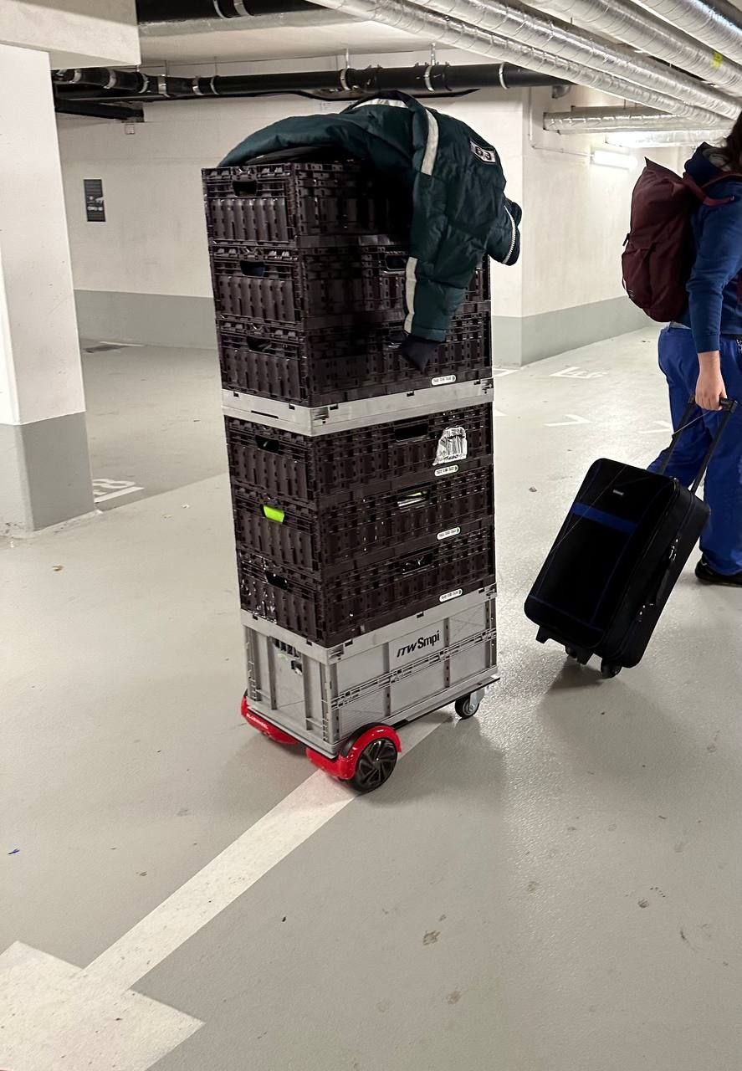
1D-Pong
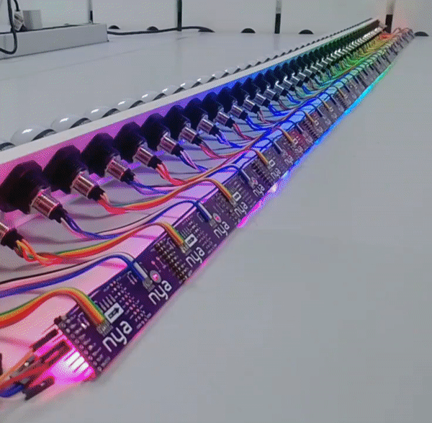
TWANG32-Hack
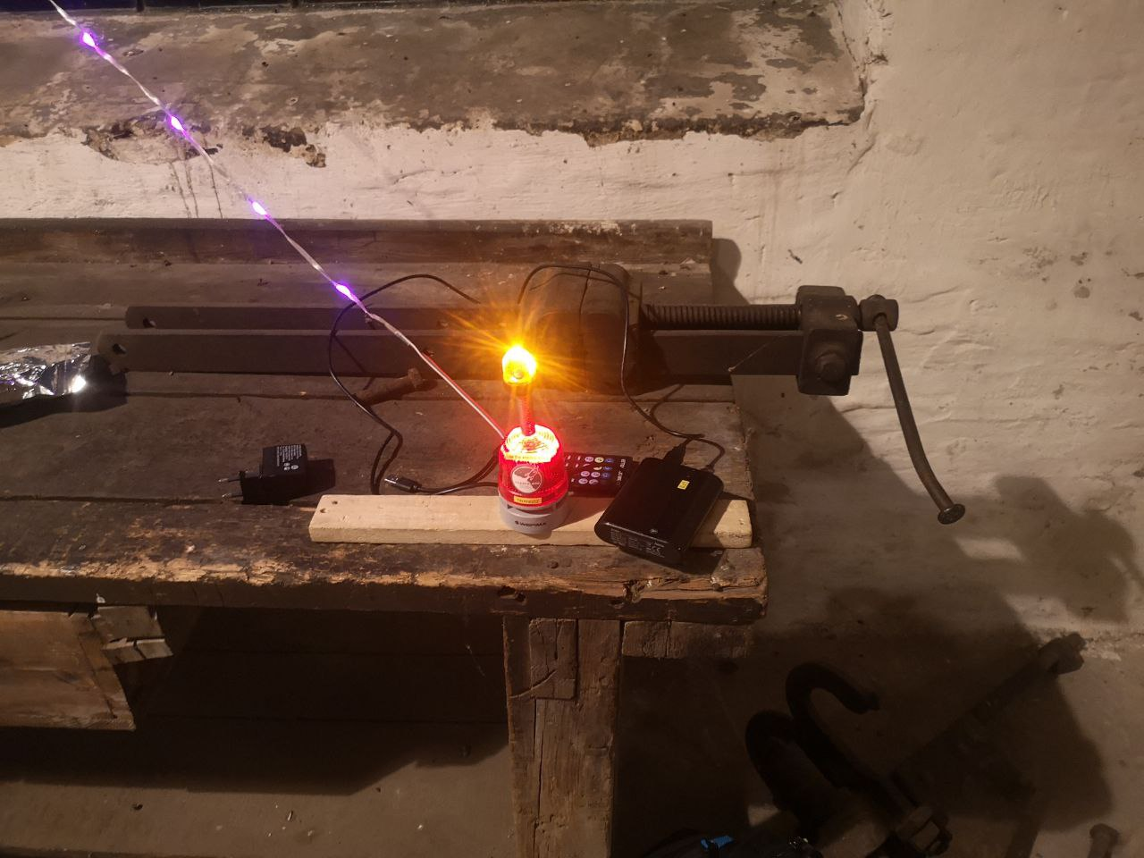
Mirror Screen
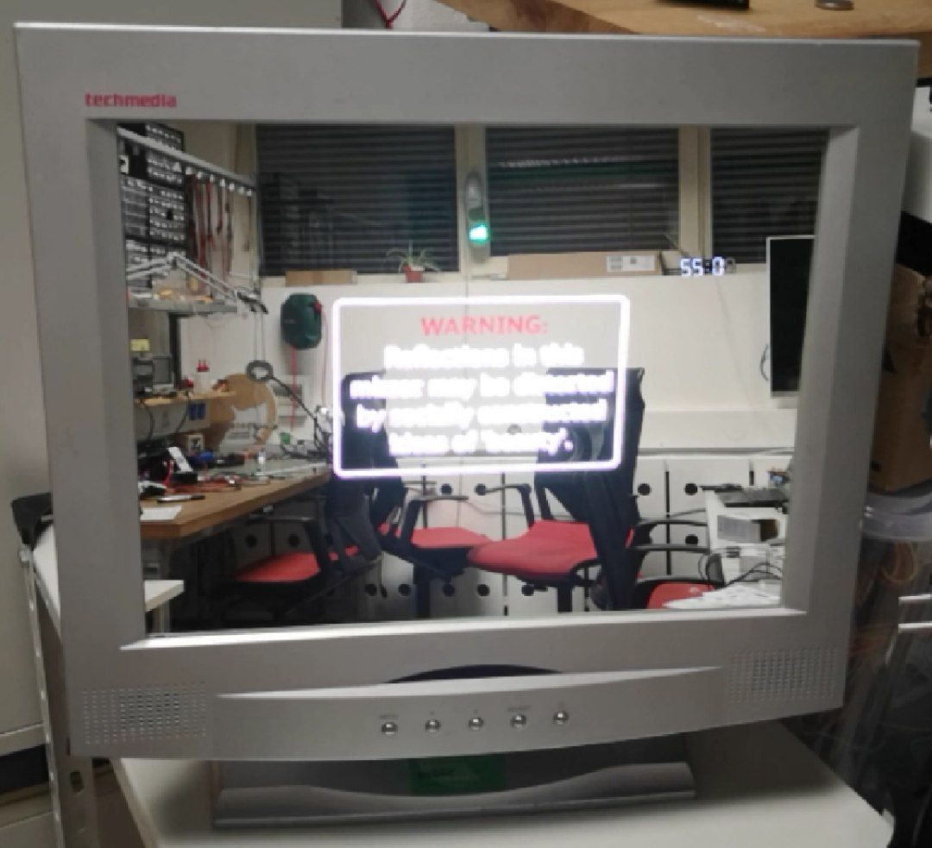
Reparatur Overlock-Nähmaschine
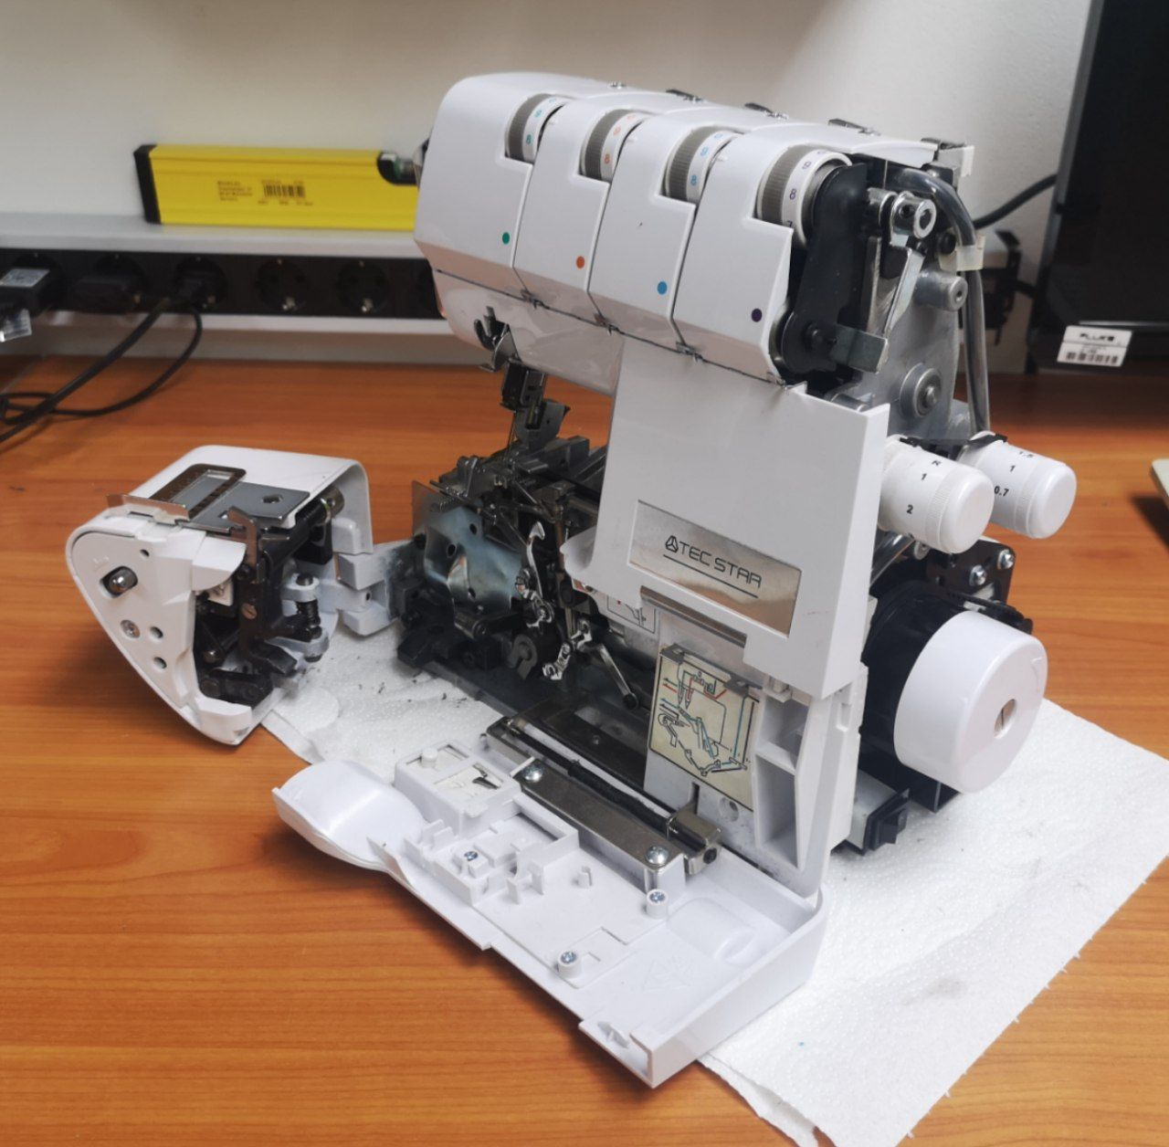
MinusEinsEnterSlashButton


